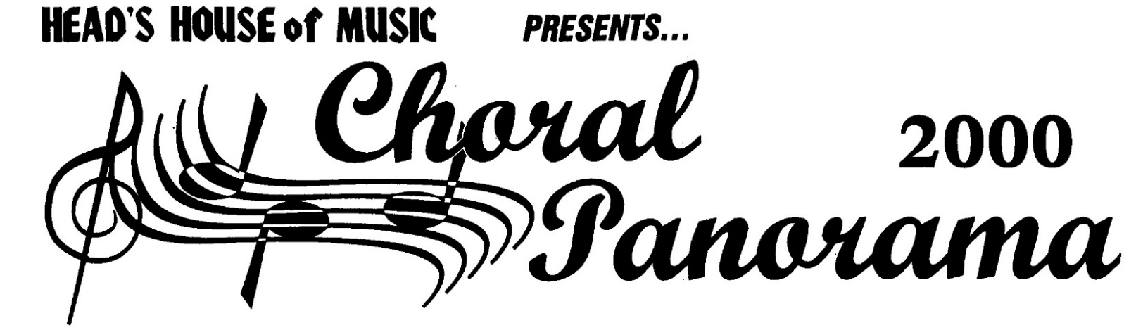
2021

Thursday July 22, 2021

Clinicians
Jonathan Palant – Roger Emerson

9:15 JONATHAN PALANT – Reading Session: “Reboot, Remix and Rejuvenate Your Repertoire”

___ | How Can I Keep from Singing | Arr. Matt and Adam Podd | SATB | $2.95
___ | Always a Place for You | Philip Silvey | SATB (SAB) | $2.25
___ | Peter Pan - Suite | Arr. Emily Crocker | SA | $2.95
___ | Ezekiel Saw the Wheel | Arr. Rollo Dilworth | SSATB (SAB) | $2.25
___ | Walking in the Air | Arr. John Leavitt | SATB (SAB, SSA) | $2.15
___ | Ave Regina Caelorum | Arr. Meredith Bowen | SSA | $2.25
___ | Blackbird | Arr. Audrey Snyder | TB (3-pt Mxd, 2-pt) | $2.15
___ | Nino Lindo | Arr. Alejandro Rivas | 3-pt Treble | $2.35
___ | Il Est Ne, Le Divin Enfant | Arr. Audrey Snyder | 3-pt Mixed (Treble) | $2.10
___ | Festejo | Arr. Diana Saez | SSAA (SAB, SSA) | $2.50
___ | Cradle Hymn | Arr. David Chase | SATB | $2.10
___ | A Prayer for Healing | Joseph Martin | SAB (SSA) | $2.10
___ | Hands | Kevin T. Padworski | SSA | $2.50
___ | A Change Has Come | R. Dilworth and J. Papoulis | SATB | $2.35
___ | Proud of Your Boy | Arr. Jonathan Palant | TBB | $2.25

10:45 ROGER EMERSON – Interest Session: “Resources for Rebuilding Your Program”

___ | Pop Rounds for Choir | Roger Emerson | Rounds | $4.95
___ | Rounds PLUS (Reproducible) | Roger Emerson | Rounds | $19.99
___ | A Cappella in Three Parts | Roger Emerson | 3-pt | $3.95
___ | Take Me Home, Country Roads | Arr. Roger Emerson | TB | $2.15
___ | Fly Me to the Moon | Arr. Roger Emerson | 3-pt Mxd (2-pt) | $2.75
___ | Stopping by Woods | Roger Emerson | SATB (SAB, 2-pt) | $2.25
___ | Red River Valley | Arr. Roger Emerson | SAB (2-pt, TBB) | $2.10
___ | J'entends le Moulin | Arr. Emily Crocker | SA(T)B (2-pt) | $2.25
___ | Shoshone Love Song | Roger Emerson | SATB (SAB,2-pt,SSA,TBB) | $2.10
___ | It's So Easy | Arr. Mac Huff | SSA | $2.15
___ | Handel's Holiday | Arr. Roger Emerson | SAB | $2.50
___ | River of Dreams | Arr. Roger Emerson | 3-pt Mxd (2-pt) | $2.25

11:45 LUNCH
______________________

Visit Our Website:
www.headshouseofmusic.com
Convenient On-line Ordering
Or order direct at headsmusic.orders@verizon.com

10% DISCOUNT on Quantity Orders

1:00 ROGER EMERSON – Reading Session: “Songs Kids Love to Sing”

___ | Dynamite | Arr. Roger Emerson | SATB (SAB, 2-pt) | $2.35
___ | The Wellerman | Arr. Roger Emerson | TTBB (SATB,SAB,2-pt,SSA) | $2.15
___ | True Colors | Arr. Tim Brent | SSA | $2.75
___ | Back Pocket | Arr. Roger Emerson | SATB (SAB, SSA) | $2.50
___ | White Winter Hymnal | Arr. Roger Emerson | 3-pt Mxd | $2.25
___ | Try Everything | Arr. Paul Langford | SSAA (SATB) | $2.50
___ | A Carpenter's Christmas | Arr. Roger Emerson | SATB (SAB, SSA) | $2.65
___ | You Can't Hurry Love | Arr. Roger Emerson | SATB (SAB, SSA) | $2.25
___ | Good Job | Arr. Roger Emerson | SATB (SAB, 2-pt) | $2.25
___ | Stand Up | Arr. Roger Emerson | SATB | $2.25
___ | Lead the Way | Arr. Roger Emerson | SATB (SAB, 2-pt, SSA) | $2.25
___ | I Will Remember You (Medley) | Arr. Roger Emerson | SATB (SAB, 2-pt) | $2.95
___ | White Christmas | Arr. Roger Emerson | SATB (SAB, 2-pt) | $2.15
___ | Yacht Rock Medley | Arr. Roger Emerson | SATB (SAB, 2-pt) | $3.25

2:10 JONATHAN PALANT – Interest Session: “The Non-Negotiables to Creating Rehearsal Room Harmony”

3:10 BREAK

3:30 ROGER EMERSON – Reading Session: “Arranger’s Choice”

___ | Songs of Hope | Arr. Mark Brymer | 2-pt Mixed (2-pt, SAB) | $4.99
___ | Sanctuary | Arr. Mac Huff | SATB (SSA) | $2.50
___ | Waves | Arr. Ron Billingsley | SATB (SAB, 2-pt) | $2.15
___ | High Hopes | Arr. Audrey Snyder | 3-pt Mixed (2-pt) | $2.25
___ | Drivers License | Arr. Mark Brymer | SATB (3-pt, SSA) | $2.25
___ | All is Found | Arr. Mac Huff | 3-pt Mixed (2-pt) | $2.15
___ | The Best of Bond | Arr. Ron Billingsley | SATB (SAB, SSA) | $3.50
___ | Deck the Hall | Arr. Philip Lawson | SATB (SSA) | $2.10
___ | Better Days | Arr. Mac Huff | SATB (SAB, 2-pt) | $2.25
___ | This is Me | Arr. Kirby Shaw | SATB (SAB, SSA) | $2.15
___ | Girl from Ipanema | Arr. Paris Rutherford | SAB (SATB) | $2.25
___ | I'm Alive | Arr. Mark Brymer | SATB (SAB, SSA) | $2.25
___ | There's a Hero | Arr. Cristy Cary Miller | 3-pt Mixed (2-pt) | $2.15

4:30 JONATHAN PALANT – Reading Session: “Survivor: On the Hunt for Quality Literature”

___ | Wannabe (As an English Madrigal) | Arr. Nathan Howe | SAB | $2.35
___ | Exsultate Justi | Cristy Cary Miller | 3-pt Mxd (2-pt) | $2.10
___ | Caliban's Dream | Emily Crocker | TBB | $2.25
___ | Threads of Joy | Dale Trumbore | SSAA (SATB) | $2.25
___ | Malakatumba | Josu Elberdin | SAB (SSA) | $2.10
___ | Birkat Habayit | Ross Fishman | 2-pt | $2.10
___ | The Language of the Stars | Katerina Gimon | SATB | $2.50
___ | The Star-Spangled Banner | Arr. Roger Emerson | SSA (SSAB) | $2.15
___ | Home | Cristy Cary Miller | SSA | $2.10
___ | Vichten | Arthur Arsenault | SSA | $2.25
___ | Welcome Home Child | Andrea Clearfield | SATB | $2.75
___ | Say Her Name | Alysia Lee | SATB (SSA) | $2.50

5:30 Everything You Always Wanted to Ask – Chat with the Clinicians

B | ORG NAME | S | ORG NAME
I | ATTN | H | ATTN
L | ADDRESS | I | ADDRESS
L | CITY | P | CITY
 | PURCHASE ORDER NUMBER

HEAD’S HOUSE of MUSIC • Tampa, FL • 813/679-5029 or Toll Free 1/800/783-8030

